Proposal Template
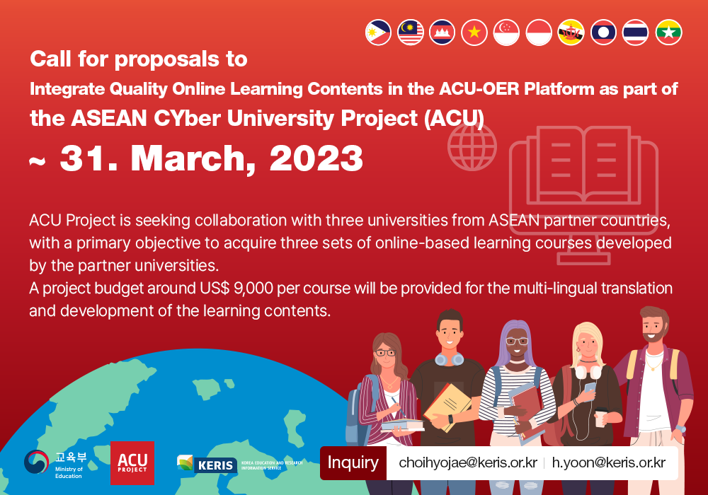

Please use the following template to apply for the "ACU Project Call for Proposals to Integrate Quality Online Learning Contents into the ACU-OER Platform.”

You are requested to kindly fill in the first 3 sections as detailed as possible, and use Section 4 to indicate any additional information you feel are necessary to share with KERIS.

Please make sure to send the following when sending in your proposal:
- One (1) set of proposal template – this file completed
- One (1) set of contents (video resources) for preliminary review
Please kindly send back the completed proposal template with any relevant materials (ex. PowerPoint slides, pdf files, etc.) no later than Friday, 31 March 2023, via e-mail to Ms. Hyojae Choi, at choihyojae@keris.or.kr and Mr Hwansun Yoon, at h.yoon@keris.or.kr. Please also e-mail any questions to the same e-mail.
We look hearing from you soon!

￭ Section 1. Applicant’s Information
Classification |  | Information
Name
Nationality
Affiliation
Position
Contact | Email
 | Telephone
Personal  information |  | Please freely include any career or experiences you feel are relevant to the KERIS collaboration (ex. Your position and main tasks in the university, your relation with the course for proposal, etc.)
Application background
and Purpose
￭ Section 2. Course Information
Classification | Information
Course title
Course objectives
Course overview
Course language
Developed year
Weekly curriculum  (Min 8 weeks to  Max 13 weeks) | Please indicated the weekly curriculum of the course.  KERIS is primarily considering courses that are comprised of  at least 8 different units and no more than 13 units.
Course duration
Number of prospective learners
Captions |  | Y | N
 | - The pre-recorded video clips of this course have captions/courses of your university’s mother language.
 | - The pre-recorded video clips of this course have English captions/subtitles.
 | - The pre-recorded video clips of this course do not have any form of captions/subtitles as of the moment.
 | - The pre-recorded video clips of this course have captions/ subtitles in both English and your university’s mother language.
 | - The course materials of this course (ex PowerPoint slides, pdf files, etc.) are already translated in English.
Copyright Holder | Please indicated as detailed as possible, copyright information about the course – in particular, whether the ACU-OER platform can openly share the course contents and use them as resources for MOOC-based classes in the ACU LMS.
Course URL | Please kindly submit with this proposal a sample clip of the course (not the entire course) for course reviewing. If the course has already been uploaded on any sites, please send their URL; otherwise please send a video file (ex. MP4, AVI, etc.)  Please be informed that all course materials submitted will be used only during the review process and will be permanently deleted once the review & designation is completed.
Satisfaction survey  Results (if any) | Please indicate information about the course’s satisfaction survey results,  if there is any.
Tentative  Work Timeframe | Please indicate the tentative timeframe indicating the time period for each task, from July to December 2021.

￭ Section 3. Instructor Information
Classification |  | Information
Name
Nationality
Affiliation
Position
Contact information | Email
 | Telephone
Personal  information |  | Please freely include any career or experiences you feel are relevant to the KERIS collaboration (ex. Your position and main tasks in the university, your relation with the course for proposal, etc.)
Application background and Purpose

￭ Section 4. Additional Information (Optional)
Please include any other information that you view are relevant to the KERIS proposal
but have not been mentioned in the three sections above.

ACKNOLWEDGEMENT: I hereby certify that, to the best of my knowledge, the provided information is true and accurate.

Applicant’s signature: ____________________________________
Date: ____________________________________

